DriverPass System Design Document

# Use Case Diagram

This diagram shows how different users (students, instructors, admin) interact with the DriverPass system, such as scheduling lessons, taking practice tests, and managing courses.

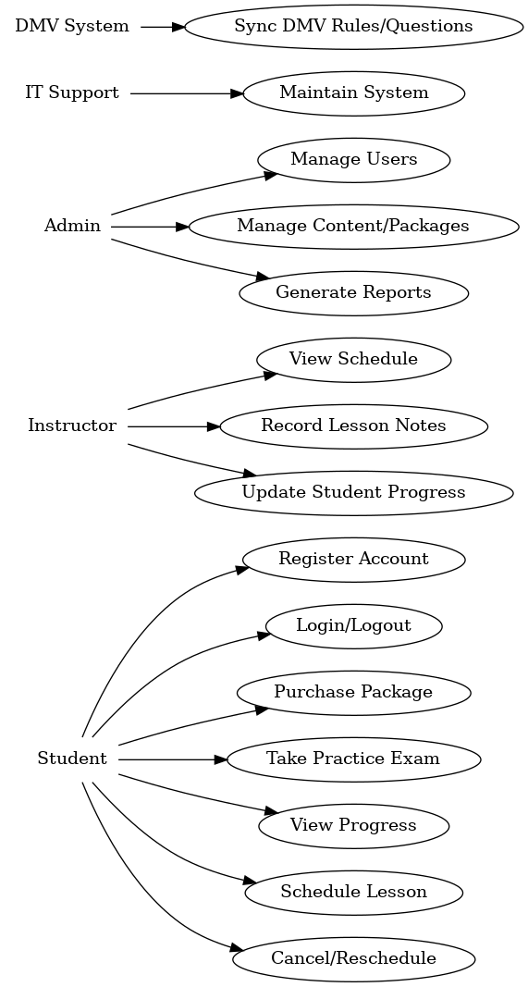

# Activity Diagram – Schedule Driving Lesson

This diagram shows the flow of scheduling a driving lesson: login -> view availability -> select time -> confirm -> schedule saved.

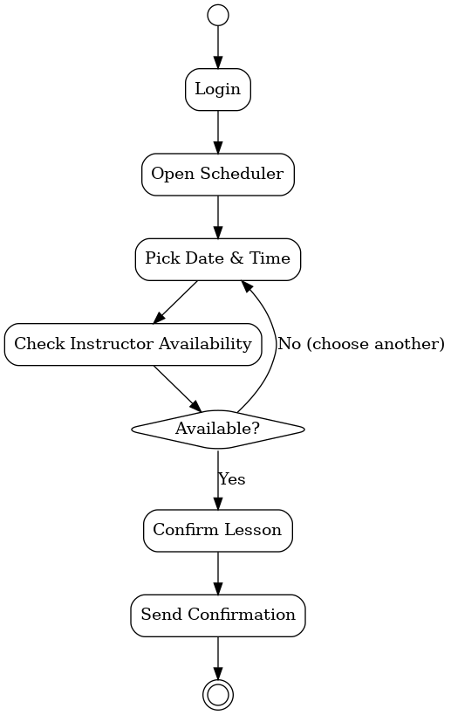

# Activity Diagram – Take Practice Exam

This diagram shows the process of starting and completing a practice exam: login -> choose exam -> complete questions -> submit -> view results.

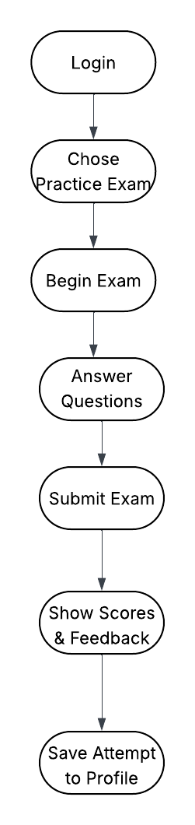

# Sequence Diagram – Schedule Lesson

This sequence diagram shows how a student interacts with the system to schedule a lesson: Student -> Web App -> Database -> Instructor schedule updated.

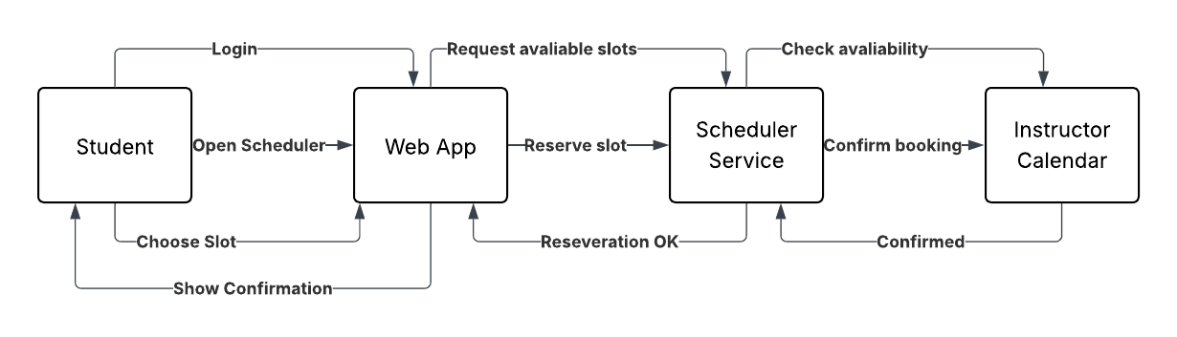

# Class Diagram

This diagram shows the main classes: Student, Instructor, Admin, Course, Lesson, Exam. Each class has basic attributes such as name, ID, and associated details.

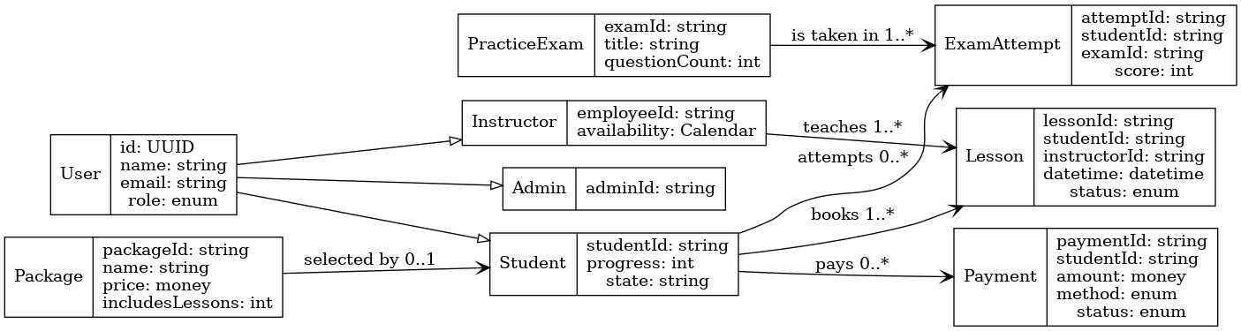

# Technical Requirements

The system requires:  
• Hardware: Web server, student devices (computers, tablets).  
• Software: Web browser, database system (MySQL or equivalent).  
• Tools: Online scheduling, exam engine, payment integration.  
• Infrastructure: Secure cloud hosting, backup, and user authentication.